Western Pacific University
Unit: CMN224 Software Engineering
Lab 6: Behavioural Diagrams for Your Client
Name: Justin Albert
ID: 00110

Part A: Use Case Diagram
No | Check before you move on | Done | Evidence
1 | Every actor is a Role, not a named person | Yes | Roles used: Bursar, office assidtance, and Head teacher [1.2]
2 | Every use case is a goal(a verb phrase the client would recognise) | Yes | Uses clear action goals like Record Payment and View Arrears Report [Part A].
3 | The system boundary is drawn. It is clear what is outside. | Yes | Outlined cleanly within the Kina Ridge Fee System rectangle [Part A].
4 | Every use case traces to a user requirement in your SRS. | Yes | Traces directly to FR-04 (Record Cash), FR-08 (Balance), FR-11 (Print Receipt), and FR-16 (Arrears) [1.3].

PlantUML Diagram
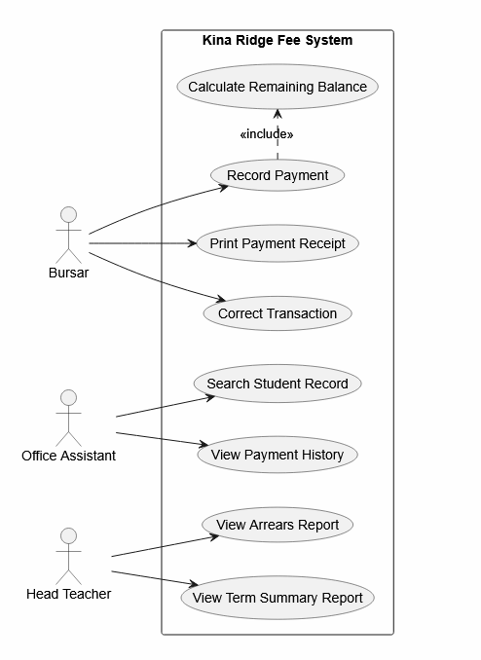
Part B: Class Diagram
No | Check before you move on | Done | Evidence
1 | Every association is NAMED (pays, generates, approves) | Yes | Explicit directional verbs used: makes, tracks, and amends [Part B].
2 | Multiplicity is shown at both ends. | Yes | Mapped accurately (e.g., One Student 1 makes Zero-to-Many 0..* Payments).
3 | At least one multicity encodes a real business rule form week 2. | Yes | Encodes installment rules (FR-07) allowing a single student (1) to log multiple separate payments (0..*) over the school term [1.1.2, 1.3].
4 | No attributes exists that your SRS never mentions. | Yes | Attributes match your exact SRS fields: studentId, paymentMethod (Cash/Bank/Mobile), and receiptNumber [1.1.2, 1.3].

PlantUML Diagram
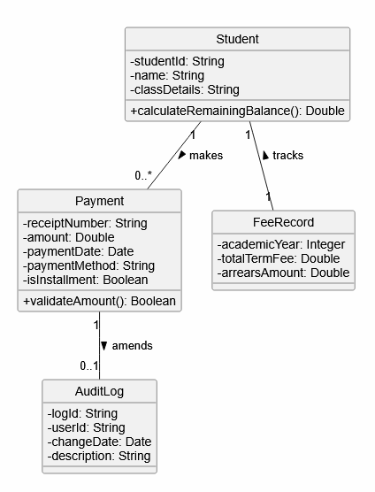
Part C: State Diagram
No | Check before you move on | Done | Evidence
1 | Every state is a CONDITION, not an action | Yes | Defines passive conditions: Drafted, Validated, SavedToSQLite, PrintedReceipt, and Amended.
2 | Every transaction name its trigger | Yes | Labeled with real user triggers like Bursar enters payment details or Click "Confirm & Save"
3 | At least on guard [in brackets] encodes a business rule. | Yes | The guard [amount > 0] acts as a hard filter to strictly enforce validation rule NFR-14 (prevent zero amounts) [1.4].
4 | There is a start state and at least one end state. | Yes | Standard entry and exit paths are cleanly bounded using standard UML [*] nodes.

PlantUML Diagram
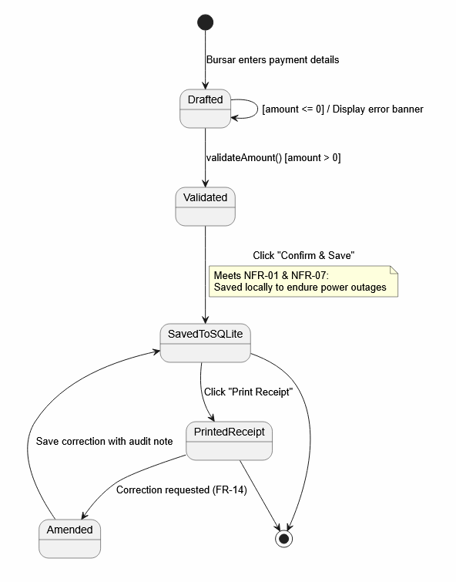

Part D: Activity Diagram With Swimlanes
No | Check before you move on | Done | Evidence
1 | Swimlanes match the devices/roles in my deployment diagram. | Yes | Swimlanes match your Lab 4 local setup: Kina Ridge Office Laptop and School Printer.
2 | There is a decision node for the offline case. | Yes | Includes the Internet/Wi-Fi Status? check to split system pathways based on connectivity.
3 | The work flow shows what staff can do while the link is down. | Yes | Explicitly shows that balance calculation, SQLite writing, and USB receipt printing run smoothly without internet (NFR-10).
4 | Duplicate-safe handling appears where data is imported. | Yes | Handled natively by forcing all active transactions to write straight into a single local SQLite database cache on the office laptop rather than syncing back and forth over a broken network

PlantUML Diagram
